Parts of a circle

- Centre: The centre is the point exactly in the middle of the circle.

- Radius: A radius is a line drawn from the centre of the circle to any point on the circumference. The radius of the circle is half the diameter of the circle.

- Diameter: A diameter is a straight line that passes through the centre of the circle and joins two points on the circumference. The diameter is twice the radius.

- Circumference: The circumference is the distance around the circle. It is the boundary or outer edge of the circle.

- Chord: A chord is a straight line joining any two points on the circumference of the circle. (The diameter is the longest chord.)

- Arc: An arc is a part of the circumference of a circle.
Minor arc: the shorter arc
Major arc: the longer arc

- Sector: A sector is the region enclosed by two radii and an arc.

- Minor sector: smaller region
- Major sector: larger region

- Segment: A segment is the region enclosed by a chord and an arc.
- Minor segment: smaller region
- Major segment: larger region

- Semicircle: A semicircle is half of a circle, formed when a diameter divides the circle into two equal parts.

- Tangent: A tangent is a straight line that touches the circle at exactly one point.

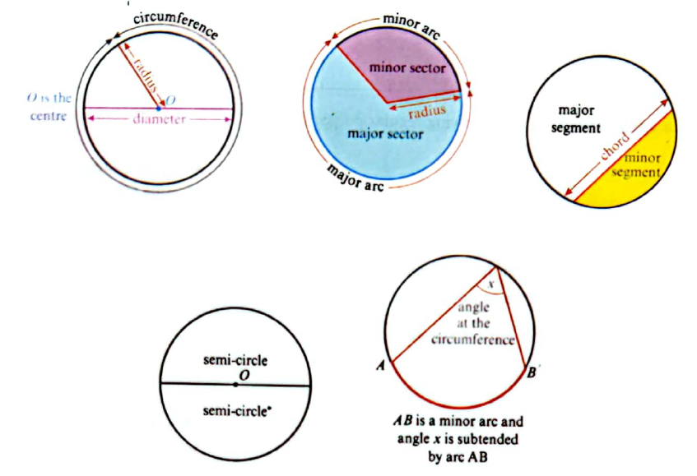

Complete the following questions in your notebook

